**Application Deployment**

**Step 1: Clone the Repository**

* git clone https://github.com/sriram-R-krishnan/devops-build
* cd devops-build

**Step 2: Dockerize the Application**

Create the following files:

* Dockerfile
* docker-compose.yml
* build.sh
* deploy.sh

Make them executable

Push to GitHub

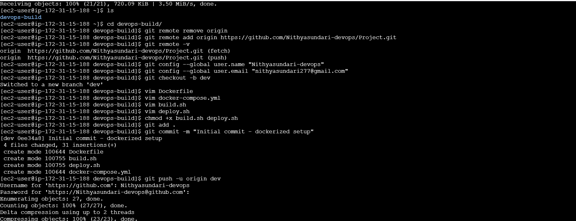

**Step 3: Docker Hub Setup**

**Public Repository**: nithyasundaridevops/dev

**Private Repository**: nithyasundaridevops/prod

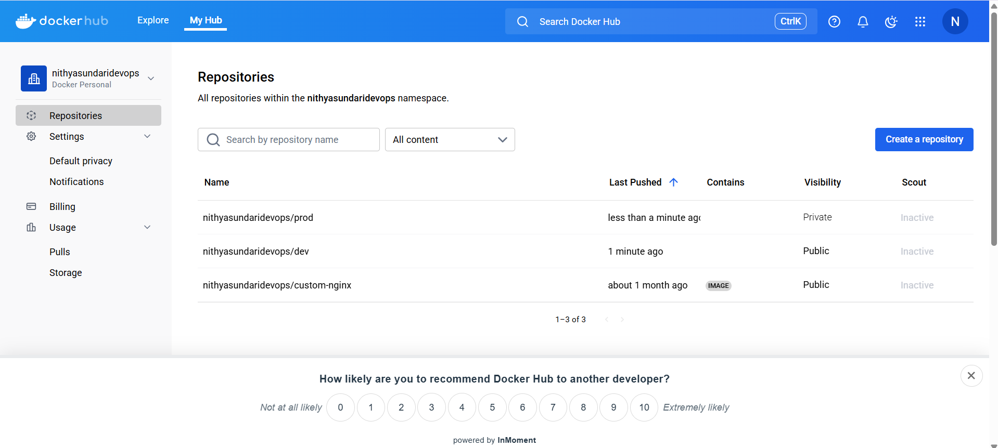

**Step 4: Jenkins CI/CD Setup**

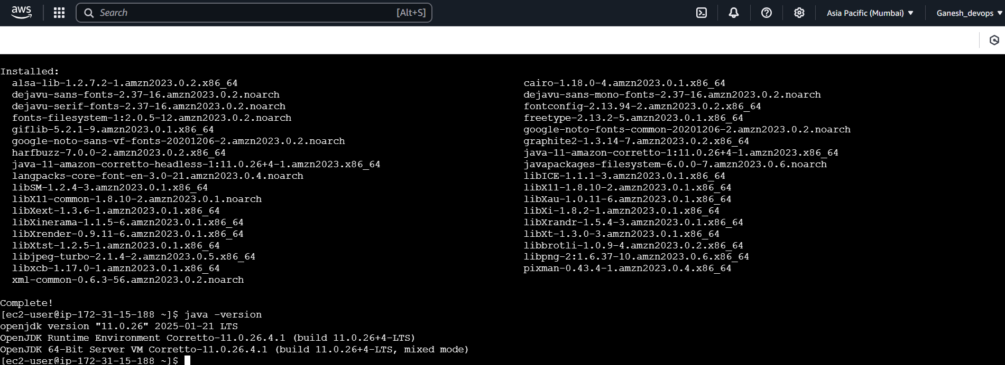

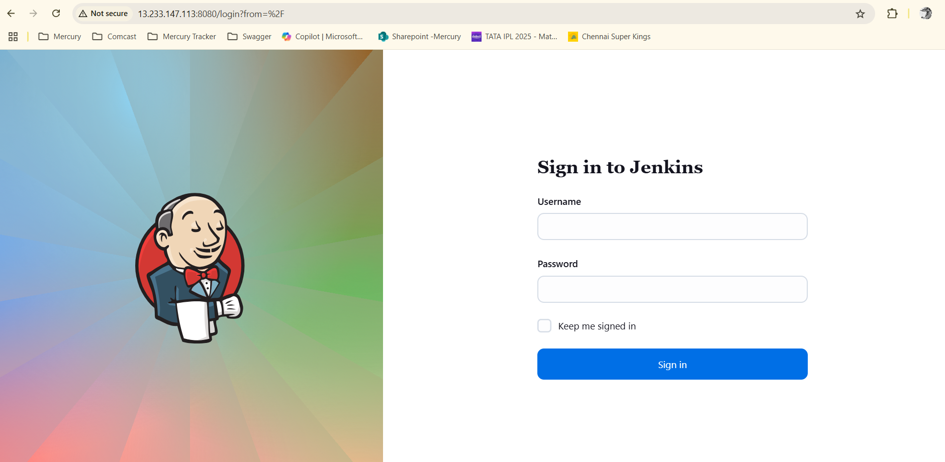

Configure Jenkins pipelines.

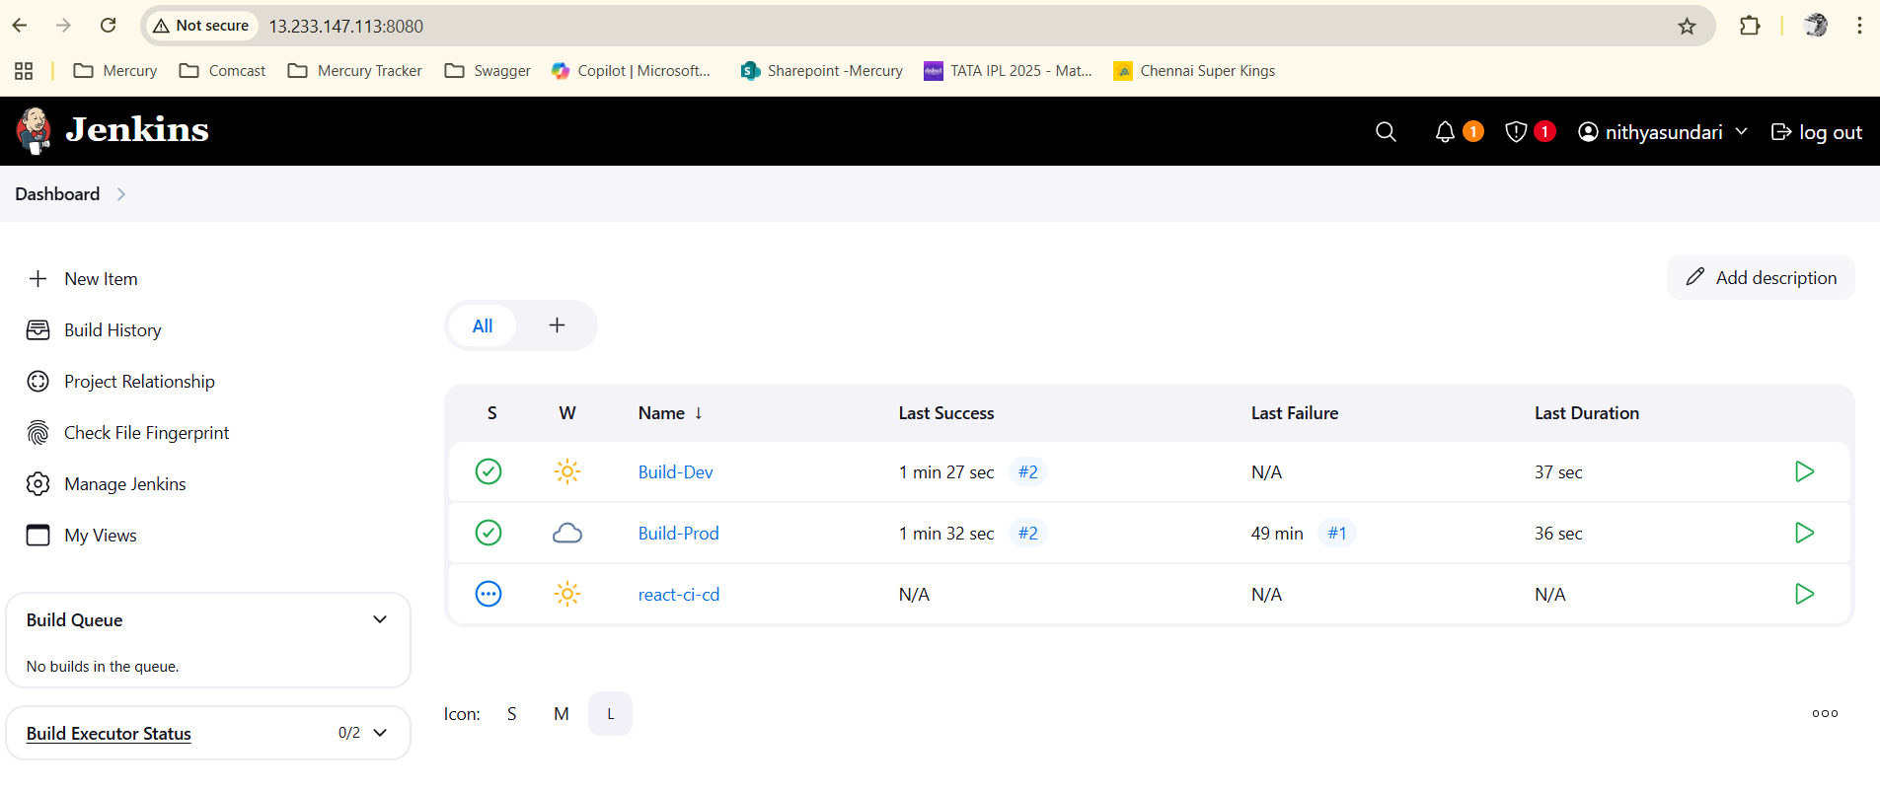

**Step 5: Create a Webhook in Github**

Set up GitHub webhooks to trigger builds on commits.

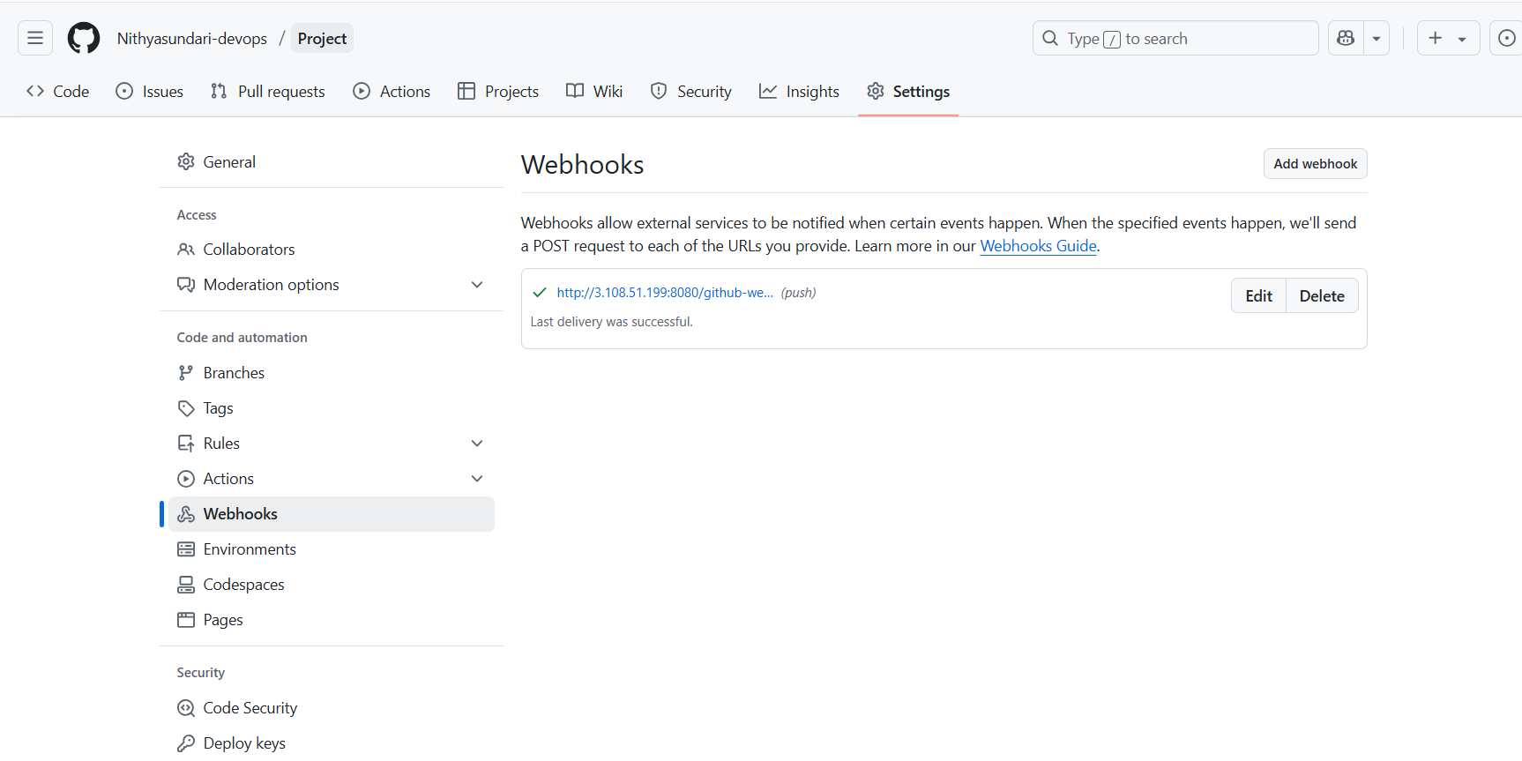

**Step 6: Docker images**

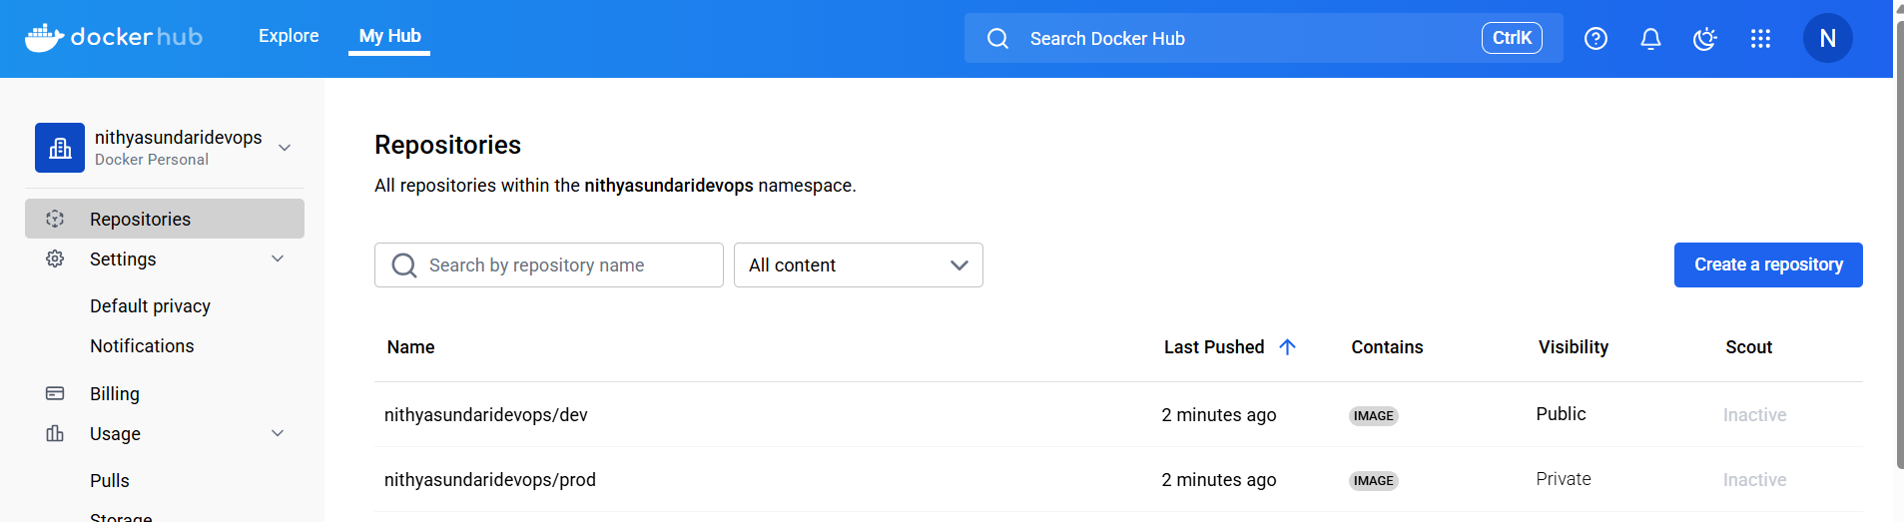

When changes are committed to the dev branch, the webhook is triggered, and a new Docker image is built and pushed to the dev repository on Docker Hub.

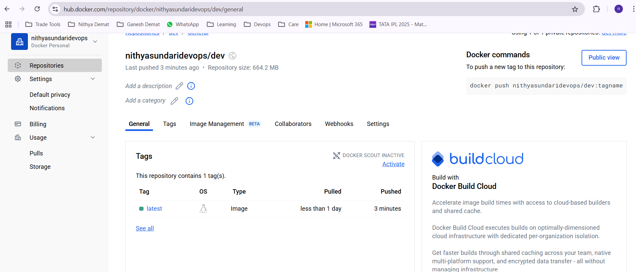

When changes are committed to the master branch, the webhook is triggered, leading to the creation and push of a new Docker image to the master repository on Docker Hub.

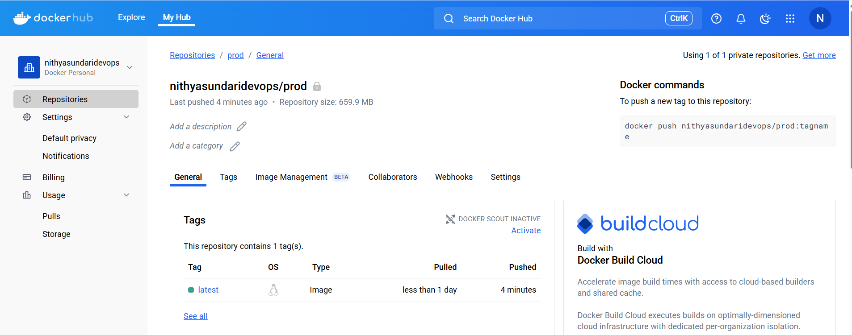

**Step 7: AWS EC2 Deployment**

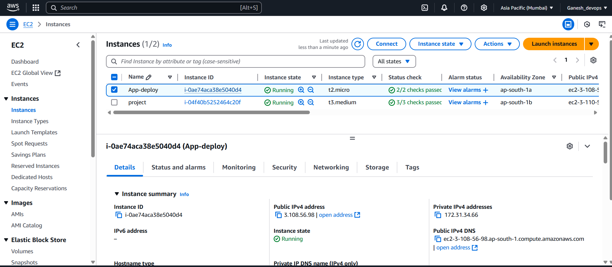

Install docker on EC2

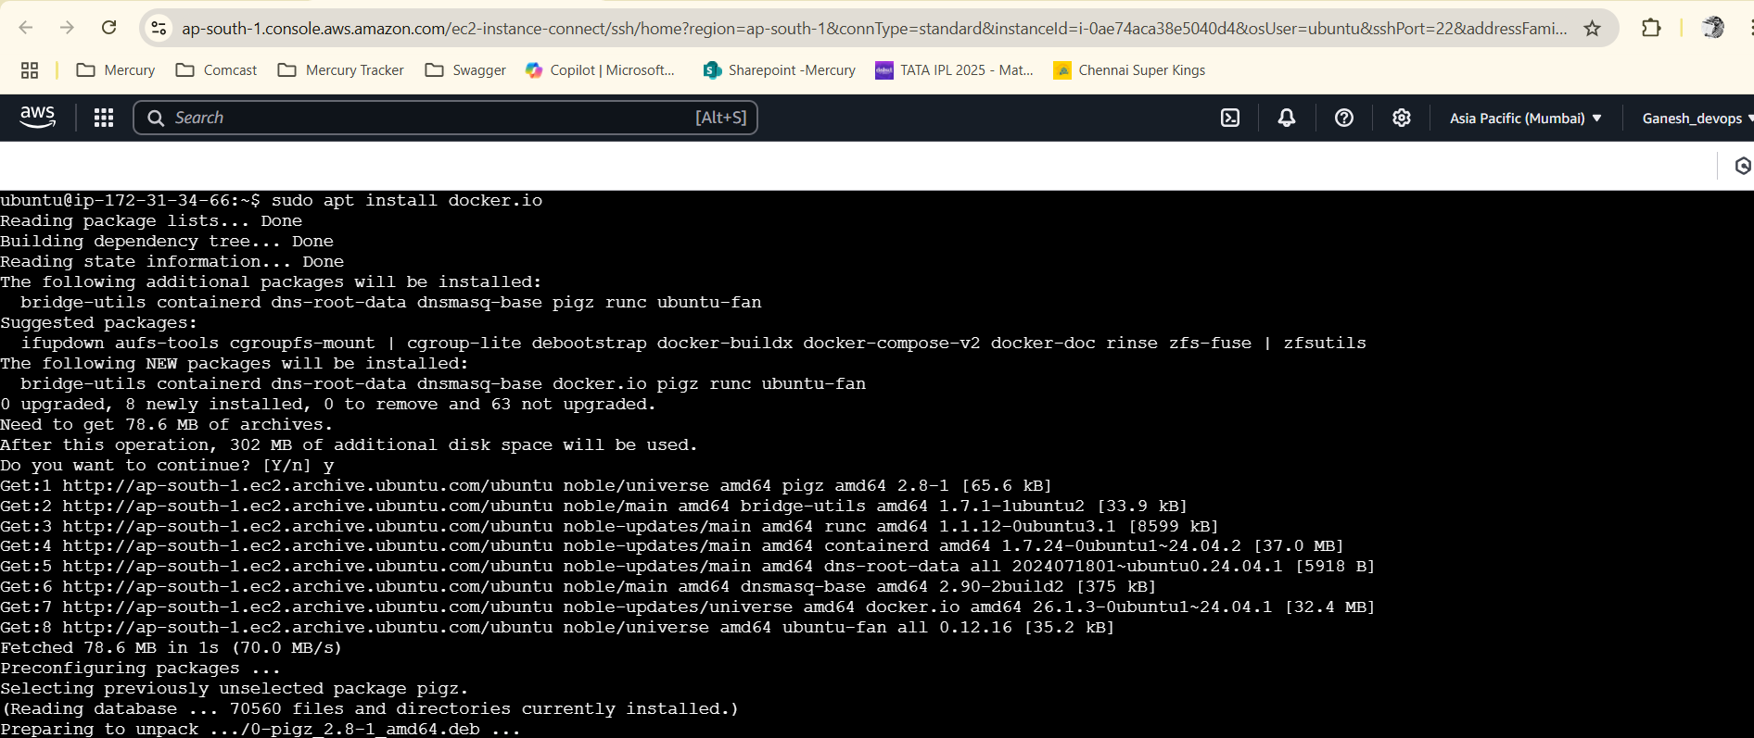

Pull the new docker image

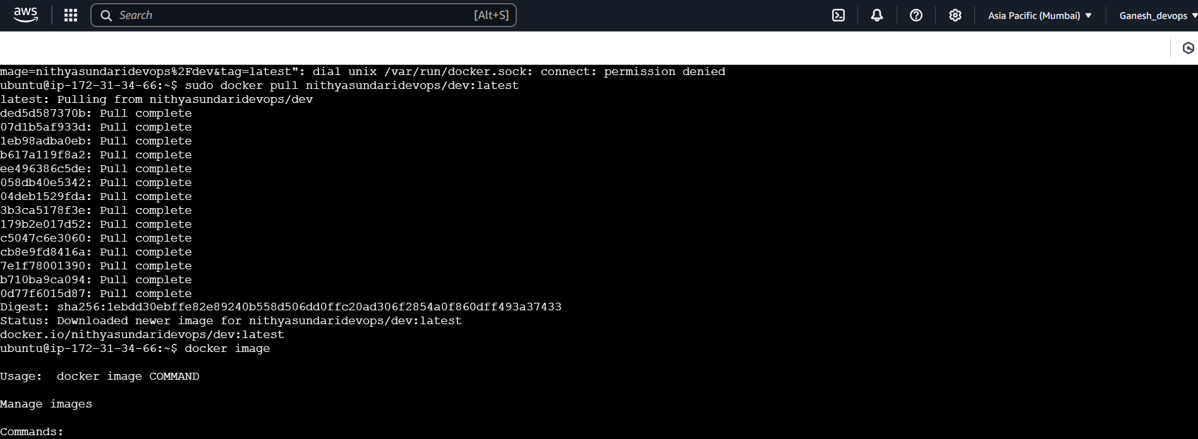

Run the docker image

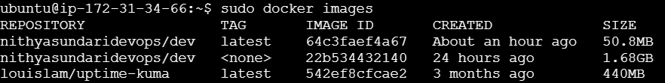



**Paste the IP into the browser to access the website.**

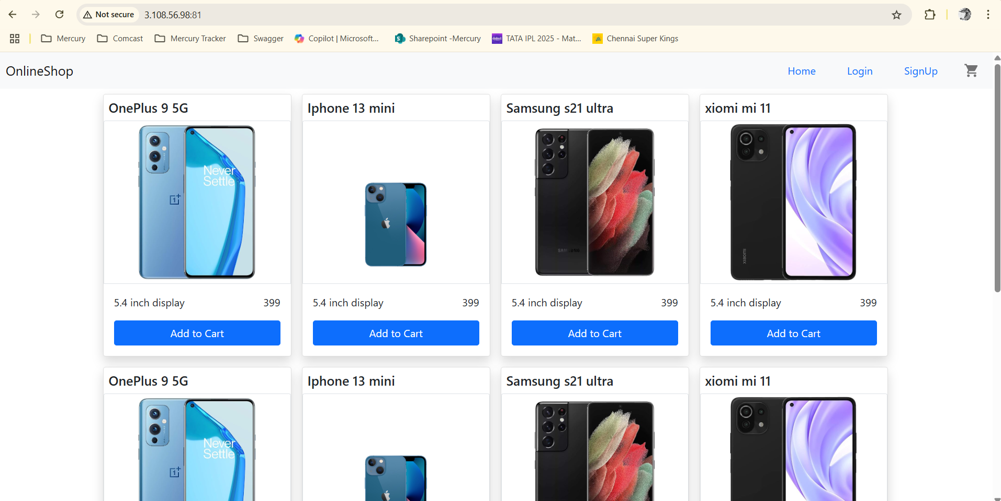

**Step 8: Monitoring Setup**

*Create a Project Directory*

* mkdir ~/monitoring && cd ~/monitoring
* Create the following files:
* Docker Compose File
* Prometheus Config
* Blackbox Config
* Start All Services
  + docker-compose up -d
* Prometheus – 9090
* Grafana -- 3002

**Grafana Configuration**

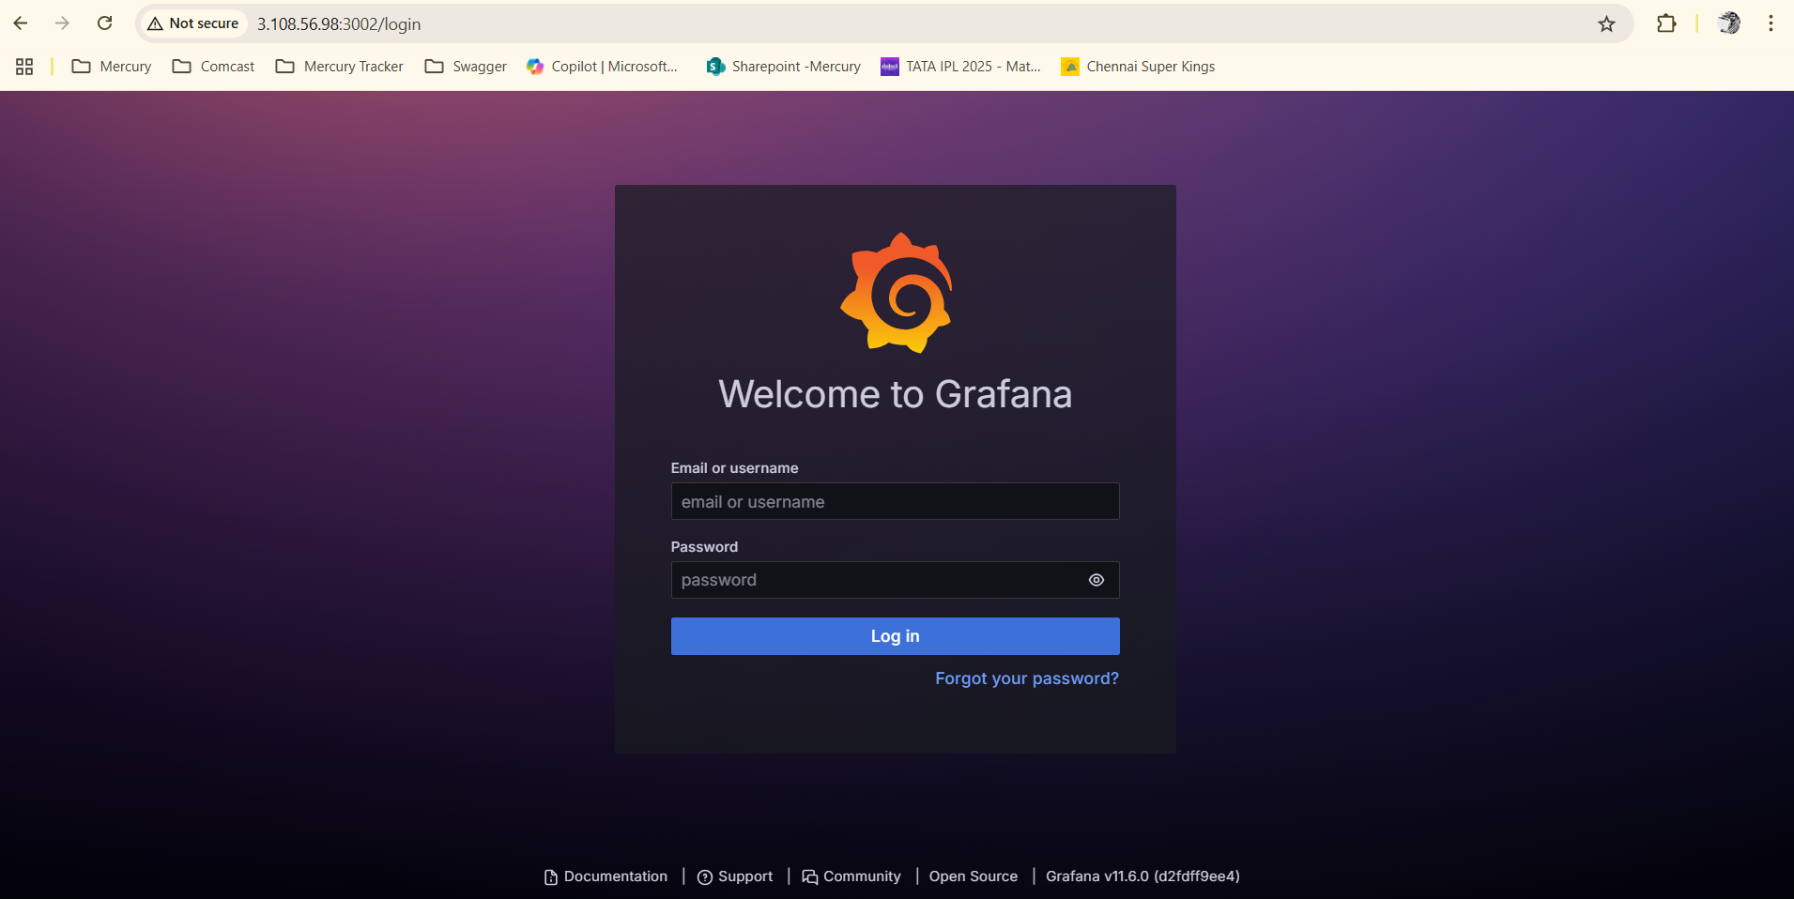

Add Prometheus as a Data Source

* URL: http://prometheus:9090
* Save & test
* Import a Dashboard
* Use ID like **7587** (Blackbox Exporter) from Grafana dashboards

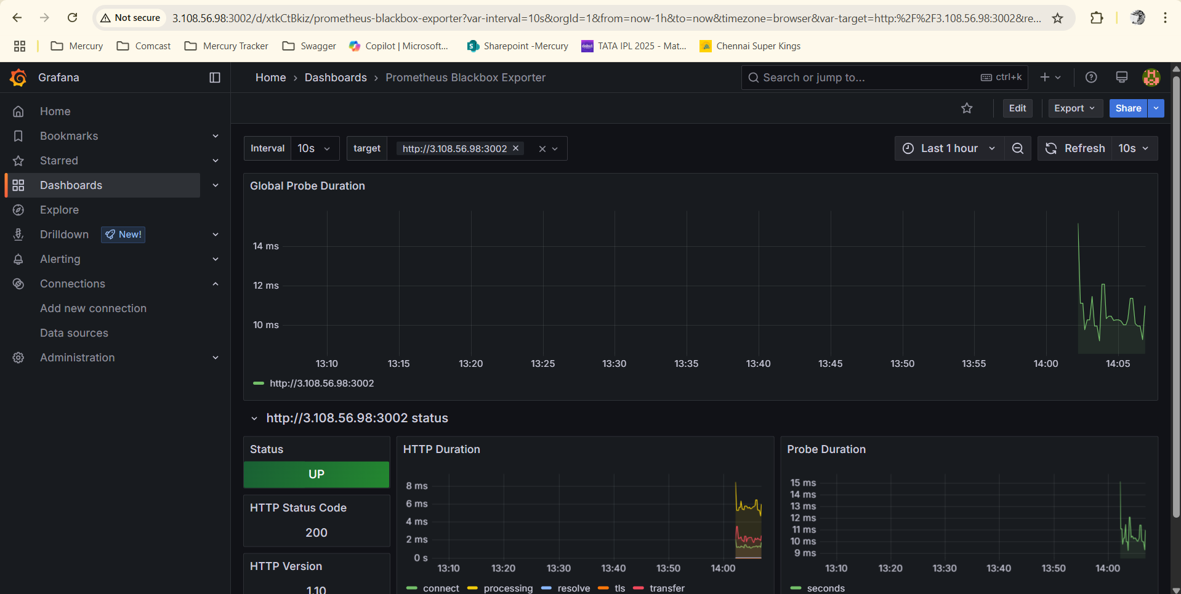

**Uptime Kuma**

Install Docker

Create a docker-compose.yml for Uptime Kuma

Start Uptime Kuma

cd ~/uptime-kuma

docker-compose up -d

**Access the UI**

http://65.0.30.217:3001

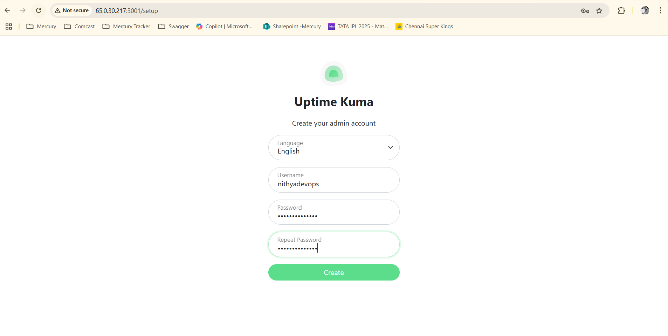

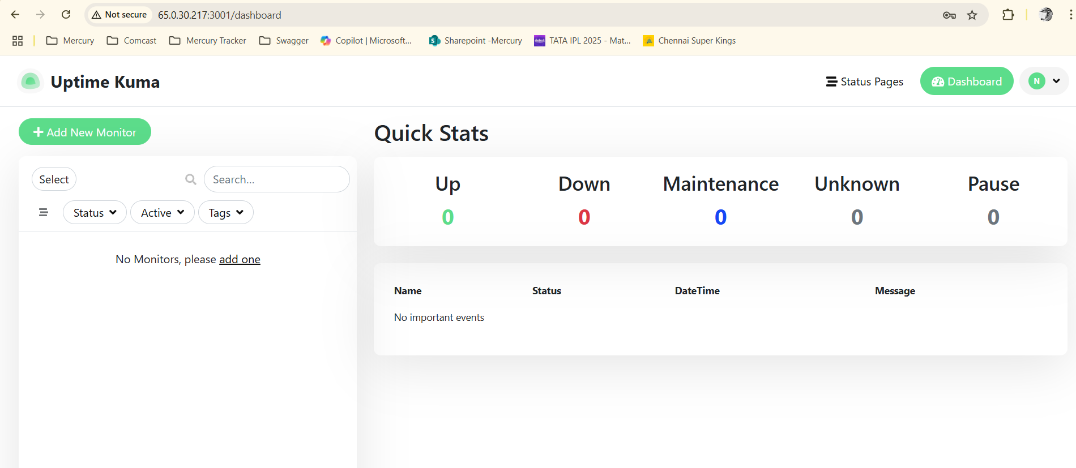

Click **"Add New Monitor"**

Choose type (HTTP(s))

Enter your app URL http://65.0.30.217:3000

Set check interval, alert settings, etc.

